A-1
LEARNING FOR LIFE
The urge to learn

1 Basic needs – Maslow
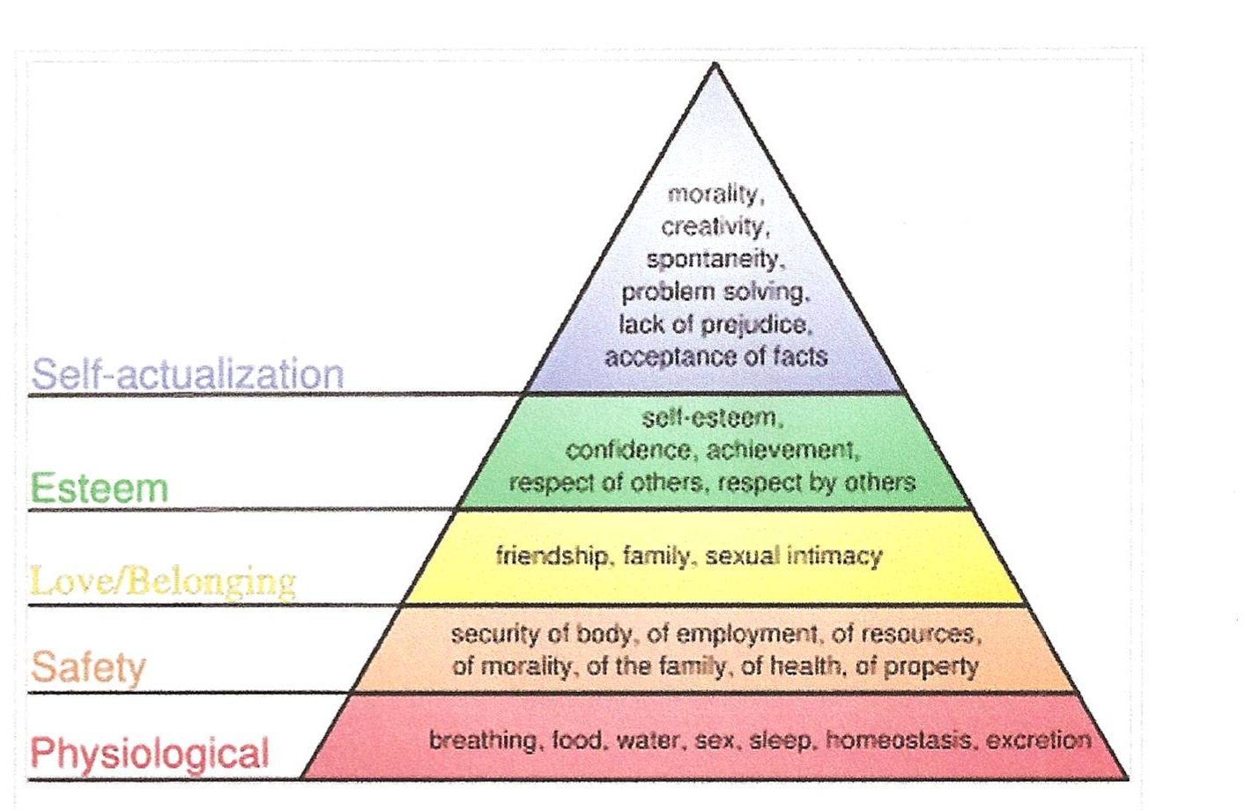

Life roles - Oregon
- Individual
- Family Member
- Citizen
- Learner
- Consumer
- Producer

